

**There are 7.98 billion (2022) people in the world and there is one thing that connects us all**



Music is the one, true international language we have. It is present in every known culture, and it has been connecting generations with a common passion for years.

**Dataset:**[**https://developer.spotify.com/documentation/web-api/**](https://developer.spotify.com/documentation/web-api/)

**http://millionsongdataset.com/pages/getting-dataset/**

**SUPERVISED MACHINE LEARNING:**

Recommend new songs / Predict new trends

**Back-End Tools**:

Data Pre-processing 

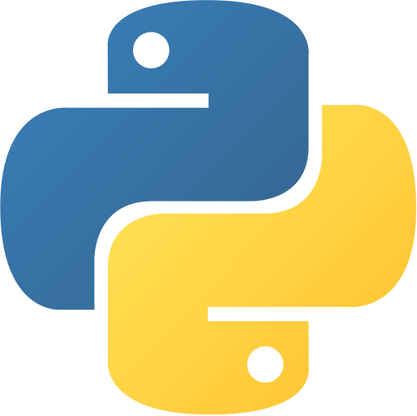  
Python

**Front-End & Data Visualisation**:

Web Design Structure

Data Visualisations

